ACTIVITY: OPERATION AND MAINTENANCE OF PAN MIXER
_____________________________________________________________________

- Objective : - Safe operation/maintenance of Pan mixer for
Proper mixing of refractory castable.
- Scope : - Blast Furnace and ladle shed area
- Ref. : - Installation & operating Instruction manual –
M/s.Esquire (OEM)
- Responsibility : -
Engineer Incharge & workmen on job

PPE –s to be used:

Safety helmet, Safety shoes, hand gloves, tight cloth, safety goggles & Dust mask

- Work No 1 : Operation of the Pan mixer
- Work No 2 : Maintenance of pan mixer

Aspect – impact:

Oil Spillage | Land contamination
Scrap generation | Resource Depletion
Oil traced waste generation | Land contamination & Resource Depletion

Hazards identified-

Mechanical Hazard:
- Fall of parts during maintenance
- Entanglement in between blades, coupling, screws, moving wheels, etc
- Entanglement of refractory bag in moving blades
- Fall / slip / overturning of mixer from unleveled area
- Rolling of pan mixer in sloppy area and hitting on structure and near by person
- Fall of refractory bag, ghameela, tools, hammer, blades
- Impact of mixer, parts, gearbox, motor etc.
- fall of castable in eyes
- Fall of mixer from height while shifting

Physical hazard:
- Fire.
- Dust inhalation from castable powder

Electrical hazard:
- Electrical Shock

Human behaviour:
1. Person working under alcohol.
2. Horseplay.
3. Not usage of PPE s like helmet and dust mask.
4. Person bypassing work instruction.

SPECIFICATION OF EQUIPMENT

TYPE : BATCH TYPE
CAPACITY : 100 LITERS
PAN DIA/HEIGHT : 900MM/400MM
SPEED OF ROTAR : 25 RPM
POWER SUPPLY : 3 HP MOTOR
TRANSMISSION : REDUCTION GEAR BOX (TYPE NU-4 50:1)

- Work No 1 : Operation of the Pan mixer

- Level the pan mixer properly on the ground and provide wheel stoppers to avoid rolling.
- Check all fasteners for proper tightness.
- Check the lubrication oil in the Gear box through sight window glass. If required, top up with Spirex 140 oil. Follow work procedure WI/MAINT/93 for topping up the oil.
- Check the coupling for free rotation with hand and check the rotation of deflector and blades
- If any abnormality is found, check the clearance between mixing blades, deflector plates and bottom plate of pan. If required reset the clearance after taking proper shutdown of the machine. (Removing the plug top).Ref drawing given below.
- Connect the pan mixer to electrical supply to 3phase pug socket of 415V.
- Ensure all safety guards of rotating parts are in position.
- Ensure that mixing media is free from any foreign materials like metal pieces, wooden piece or any other hard material
- Ensure that pan is completely empty before starting. This will reduce undue starting torque development; hence will reduce overloading of motor.
- Start the machine and check for the direction of rotation (clockwise when viewed from top) Keep the machine ON before starting the mixing operation.
- Castable or mortar to be added to pan gradually through top feeder only in running condition and add water to it depending on the requirement of application. Never attempt to feed the material other than chute.
- Take due care to avoid entrapping of the cloth or any other free bodies in the rotating media.
- Inspect the pan during running for proper mixing.
- Discharge window of mixer to be opened for discharging the mixed refractory material in running condition.
- Clean pan of the mixer thoroughly with clean water after mixing of refractory.
- Stop the machine and remove the plug top.
- Carry out the housekeeping of the area as per work procedure WI/MAINT/91.

- Work No 2 : Maintenance of the Pan mixer

- Take the vibration level of the pan mixer at fixed location of gear box and motor. If the vibration level is high, plan for the alignment/balancing of the equipment.
- Ensure proper electric shutdown of the equipment before starting the maintenance operation (Removal of plug top).
- Clean the pan mixer thoroughly using the water. Ensure the motor is properly covered to avoid fall of water on it.
- Carry out the structural stability of the frame of the equipment and repair if required. Refer SP44 for welding and gas cutting.
- Check the lubrication level in the gear box if require top up the oil as per WI/MAINT/93 lubrication procedure.
- Find out the source of oil leakage such as of leakage from oil seal, gauge, gear box body crack etc and take relevant steps to prevent the same.
- Check and tighten all the fastener of the pan mixer.
- Check for the rubber cushion and nut & bolt of the couplings.
- Check the clearance between mixing blades, deflector plates and bottom plate of pan mixer and if require reset the clearance.
- Check the wear of the mixing blade & deflector plate. if require change the same.
- Take the trail of the machine with NO load and load condition. Check the operating parameters like electrical current, speed etc,
- If Operating parameter found OK, machine can be taken for operation.

Note:-

- In case of any power failures or emergency stop, don’t restart the mixer. In such case, first empty the pan, restart the machine and recharge the castable.
- Mixing media must be free of any foreign materials like metal pieces, wooden piece or any type of hard materials as it may damage the rotating parts.
- Before cleaning the pan manually ensure that pan mixer is disconnected from electrical supply.

DO NOT:

- Use wear loose cloth while working on the pan mixer.
- Insert any rods inside the moving mixer
- Bypass the feed chute for feeding materials

Drawing for Deflector Blade setting of Pan mixer

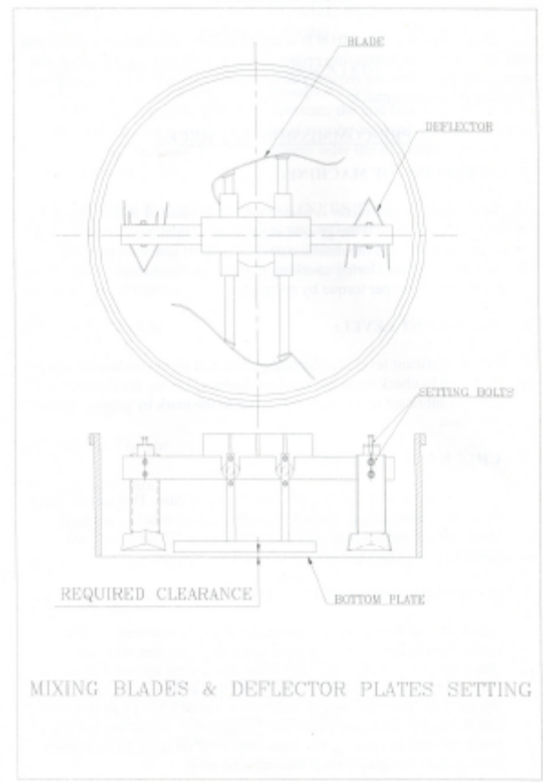 - For Refrence Only

Amendement Record
Date | Manual Section Ref. & Para | Brief details of Revision | New Rev.

Prepared By:  Area Engineer | Reviewed & Issued By:  Management Representative | Approved By:  Mechanical Head
Signature | Signature: | Signature:
Review Date: 12.12.22 | Review Date: 12.12.22 | Review Date: 12.12.22

